USER REQUIREMENTS

The Bidder should provide the following in the specified order in Section 4 of the proposal/bid document.

Provide detail information of the proposed solution as per document enclosed. Please note that marking should be carried out in the following manner; The Remarks column should be used to explain or provide detail information.

DESCRIPTION | REMARKS
Rating - 5 | If the User requirement is met 100% as defined in the RFP without any work around method.
Rating - 4 | If the User requirement is met 75% as defined in the RFP without any work around method. Define the number of hours required for the modification and cost in US$ in the Remarks column, in order to provide 100% functionality as defined.
Rating - 3 | If the User requirement is met 50% as defined in the RFP without any work around method. Define the number of hours required for the modification and cost in US$ in the Remarks column, in order to provide 100% functionality as defined.
Rating - 2 | If the User requirement is met 25% as defined in the RFP without any work around method. Define the number of hours required for the modification and cost in US$ in the Remarks column, in order to provide 100% functionality as defined.
Rating - 1 | If the User requirement is met as a Work around method defined in the RFP. Define the number of hours required for the modification and cost in US$ in the Remarks column, in order to provide 100% functionality as defined.
Rating - 0 | If the User requirement is not met as a defined in the RFP and modifications are required. Define the number of hours required for the modification and costs in US$ in the Remarks column.

The NBL rating is as follows:
1 = critical; 2 = essential; 3 = nice to have

E WINDOW / ONLINE BANKING
Ref : | User requirements | NBL Priority | Bidder’s Rating | Bidder’s Remarks
 | Functions Required
 | Transaction processing such as,  Customer cheque printing (only E Window)  RTGS payments  Internal transfers  Internal transfers (3rd party)  Pay orders  Drafts  Outward TTs  Outward SLIPS  Fixed Deposit placement  Treasury investments  FD & Treasury upliftments  Stop cheque instructions  Cheque book requests  Standing Orders  Customer requests through E Window to minimize paper work (faxes)  Send mails option through Lotus Notes  Automated customer reply for transactions authorized in ONLINE system | 1 | 4 | Handled by T24 ARC functionality.  Temenos ARC has been developed to provide banks using T24 with a modern, scalable and fully integrated personal retail, corporate and private front office banking solution. All business functionality for ARC modules is within T24.  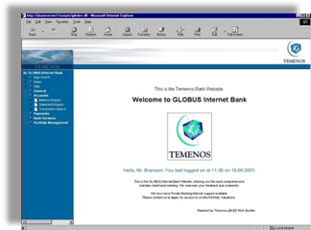  For example:  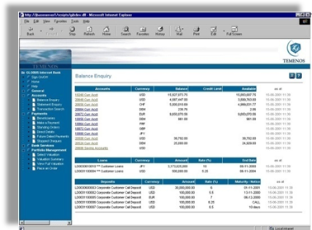  Some local enhancement may be required for certain requirements such as sending mails through Lotus Notes.
 | Inquiry
 | Customer search by CID, NIC, NAME  Transaction report transmitted & processed  Authorized signatories (chq printing – signature storing) |  | 5 | Supported by T24 through the system’s powerful enquiry search functionality.
 | Reports
 | Following reports should be generated automatically.  Summary of transmitted transactions  Summary of processed transactions  MIS reports should be available  Chq printing report  Chq spoiled report  Signature add / remove report  User creation / re-generation / customer change password / user modification | 1 | 4 | T24 provides two powerful designer tools (Enquiry Designer and Report Designer) to enable Bank to define reports. In addition, T24 includes standard enquiry and report templates which Bank can use to construct its own report/enquiries in a relatively short time frame
 | Stock maintenance
 | Facility to input bulk stocks to the E Window system  Report should be able to generate in order avoid using physical stock card  A notification should be generated (ideally an email) at the re-order level (re-order level is to be defined by the bank user) |  | 4 | Local enhancement required.
 | Transaction processing |  | 5 | Supported by T24
 | All customer requests (refer Ref : 2) should be able to upload to the core system with dual authorization (except for Chq printing & restricted products)  Customer should be able to send mails (requests) through E Window to minimize paper work (faxes)  Chq printing & debiting charges should be automated  E Window charges (rental) should be able to fed to the system and it should get debited automatically on specific due date.  E Window Chq Printing signatures should be picked by the core system  Customer data to be picked from core system when creating USER IDs  User lock & unlock facility  User suspend & re-instate |  | 5 | Supported by T24.
 | Controls |  | 5 | Supported by T24
 | Customer transaction processing should be dual control  All tax parameters should be incorporated  Products to be restricted as per Central Bank regulations  Audit trail should be available |  | 5 | Supported by T24
 | Integration with other systems | 1 | 4 | Local interface development is required.
 | Integration and interfacing with other modules is highly required. | 1 | 5 | Supported by T24. It is assumed here that the modules are all within T24. T24 being a fully integrated system hence does not require interfacing between the modules.
 | All rates should be updated on a daily basis |  | 5 | Supported by T24

